Droplet Structure Formation at the Spray Edge

J. Heinlein¹, R. Körich-Decker², U. Fritsching¹
¹Process Engineering Department
University of Bremen∗
Bremen, Germany
²School of Chemical Engineering – FEQ
Universidade Estedual de Campinas
Campinas SP, Brazil

Abstract
The behaviour of sprayed droplets is studied in the outer edge region of liquid sprays. Here structure formation occurs within the interaction of the droplet laden flow with the gas in the spray itself and in the mixing process with the coherent structure gas flow in the vicinity of the spray. Main aim of the investigation is the analysis of such unsteady spray conditions at the spray cone edge within liquid atomization and the spray formation. Therefore, the interparticle arrival time distribution concept has been derived for certain spray conditions and spray situations in a spray of a twin-fluid atomizer. For modeling the ideal spray situation, the interparticle arrival time distribution is studied also in two-phase jets with solid particles. The formation of vortex structures in particulate shear flow is studied additionally within simulations. Thus, criteria for droplet cluster formation in the spray are derived.

Introduction
The mixing behaviour of a certain spray with its surrounding ambient gas is of large importance for the spray process efficiency as the determining heat and mass transfer processes depend directly on this mixing behaviour. Gas entrainment into the spray jet is the main process that influences this mixing behaviour. The gas entrainment process mainly is due to shear flow conditions and pressure gradients between the spray and its surrounding. Main parts of the mixing, especially in the spray development zone close to the atomizer, are due to the establishing of large scale (coherent) vortex structures. The most important mechanism for the establishing of coherent structures in shear flows is the Kelvin-Helmholtz instability mode.
This study focuses on the establishing of coherent structures in spray processes and the reaction of the particulate (droplet) phase in the spray to this large scale structures.
Experimental characterization of spatial and/or temporal drop distributions in sprays may be based either on area distributions (for droplet concentration or droplet flux) or may be based on single point statistics characterizing the droplet properties at discrete points in time or space. Such a description may be used to derive the droplet number density or flux rate. Non-intrusive point wise particle measurement techniques as e.g. the Phase-Doppler-Anemometry allows the additional detection of time series information in particulate flows. In this connection a multipoint statistical description of a spray has been adopted. Based on this theoretical framework it is possible to distinguish between steady and unsteady sprays by using the local interparticle arrival time between successive droplets at a certain location. Steady sprays are defined as those whose interparticle arrival time distribution obeys inhomogeneous Poisson statistics. Unsteady sprays are defined as those whose interparticle arrival time distribution do not obey inhomogeneous Poisson statistics.
For the determination of the steady and/or unsteady behaviour of a spray, a certain place at the edge of the spray cone is observed by the probe volume of the PDA. Here the interparticle arrival time statistic is determined. Each particle exhibits in addition to its characteristic size and velocity the interparticle arrival time as another characteristic. A typical example of unsteady behaviour is droplet clustering caused e.g. by the formation of large-scale eddy structures in shear layers.
The formation of droplet clusters in a spray will have significant impact on the related heat and mass transfer processes between the liquid phase within the droplets and the gaseous phase.

Specific objectives
Main aim of the investigation is the analysis of unsteady spray conditions in the spray cone and here especially at the spray edge within liquid atomization and spray formation. Therefore, the interparticle time distribution has been employed for certain spray conditions and spray situations in the spray of a twin-fluid atomizer.
For comparison with the spray process, the interparticle arrival time distribution is studied in two-phase jets laden with solid particles.
Also, the formation of vortex structures in particulate shear flow is studied by computational fluid dynamics of two-phase flow simulations. Here the mixing and demixing process of different sized solid particles is studied in a plane shear layer as example.

Experiments and Simulations
For experimental analysis of cluster formation of particles or droplets in a two-phase flow situation, the interparticle-arrival-time analysis has been employed. Within a point wise determination of two-phase flow properties, the interparticle time is the time increment between two successive particles passing a certain location (point of measurement).
The interparticle arrival time analysis for two-phase flow analysis has been developed by Edwards and Marx [1, 2] for sprays. A modified version of the interparticle histogram and its acquisition in sprays was presented by Heinlein and Fritsching [3]. In this context the theoretical interparticle function is compared with the experimental interparticle distribution function and a decision on particulate flow steadiness or unsteadiness is made. The steadiness of the dispersed flow is a measure for the demixing of particles from the carrier flow and the formation of particle clusters. In a steady flow the interparticle arrival time distribution obeys a Poisson statistics. When a significant derivation from the Poisson distribution is observed, evidence is given that the dispersed flow situation shows deterministic demixing of the particles, thus the formation of particle clusters.
The statistical analysis of the chi-square (Chi²) test is used to obtain the significance, or confidence level, within which the experimental results can be argued to be the same as the theoretical values. In a chi-square analysis, the calculation of the random variable Chi², the deviation of the observed values to the corresponding expected values, can be measured and can determine the validity of the hypothetical model (Luong and Sojka [4]). Once Chi² has been determined, the hypothetical model can be accepted or rejected depending on the desired significance level.
The detection of the relevant interparticle time series at certain point wise locations for the spray and jet analysis has been realized with a Phase-Doppler-Anemometry (PDA) arrangement.
For the spray to be analysed a twin-fluid atomizer is used. The spray produced by the atomizer has a full cone shape. The mass flow rate of water to be atomized has been fixed at 7 10⁻⁴ kg/s. The gas pressure has been varied between 0.02 MPa < p_{g} < 0.1 MPa. The central plane of the spray was scanned for analysis at r < 40 mm and 50 mm < z < 200 mm.
The particle laden jet is prepared in the following ways. The gas/particle mixture exits a round nozzle of 12 mm diameter into the direction of gravity. A free jet forms that is analysed at certain axial and radial positions in the area r/R < 5 and z/D < 20. For the present investigation spherical glass particles of 50 µm are used at different gas exit velocities between 8 and 16 m/s. Thus the spectrum of Reynolds number is 5372 < Re < 10744 and the particle Stokes number range is 50 < St < 160. The specific solids loading of the jet has been varied between 3 and 7.
For analysing the behaviour of different sized particles (in terms of the particle Stokes number) and the interaction of gas coherent vortices and the droplets, a numerical simulation study has been performed. The simplest case for coherence vortex formation has been chosen. This is the plane shear layer between two adjacent and parallel flowing gas streams behind a splitter plate, both flowing at different speeds. The simulation is based on a viscous modeling of the gas flow, excluding turbulent effects. Therefore, the conservation equations for mass and momentum are solved in a finite volume approach. The particles are tracked through this flow field, thereby studying their response to the velocity fluctuations in the carrier gas flow. The fundamental approach is in the analysis of different particle Stokes numbers [6, 7], that is defined as the ratio of the particle relaxation time to the fluid integral time scale:
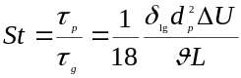
Three different Stokes number regimes will be studied, namely droplets with St << 1, droplets with St of unity and droplets with St > 1.

Results and Discussions
The spray produced by the twin fluid atomizer is illustrated in Figure 1. The formation of regions with higher droplet concentration and with lower droplet concentration is to be seen.

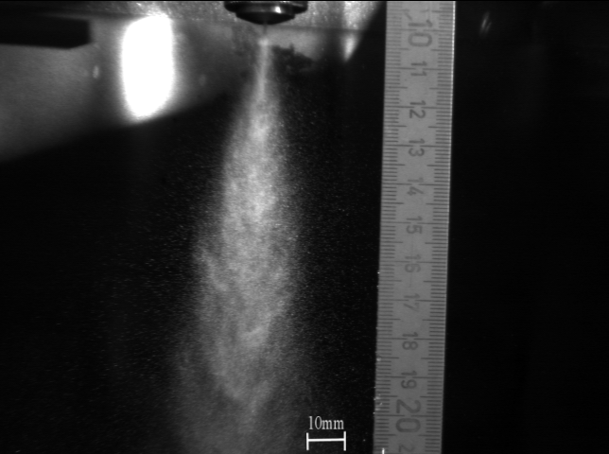

Figure 1: Spray of a twin-fluid atomizer

Figure 1 illustrates the dispersed particle laden jet by a laser light sheet photograph. The entrainment of gas within the formation of coherent structures of the two phase jet is illustrated by means of the arrows. At a well defined frequency the formation of particle structures is to be seen. The illustration at two different times shows the steadiness of the structure occurrence.

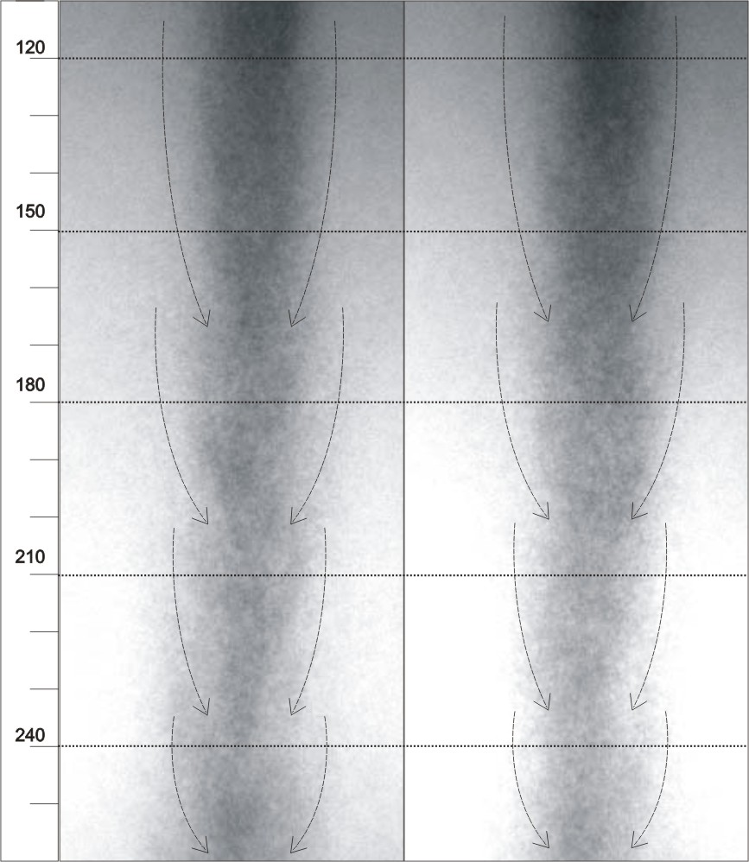
Time 1 Time 2

Figure 2: Laser light sheet through the central plane of a dispersed two-phase jet a two different times

Figure 3 shows the results obtained by Chi²-tests of the interparticle arrival time distribution for different jet operational conditions, here the jet axial gas velocity. Each distribution is taken at a different axial position from the jet outlet between z/D = 10 and z/D = 20.
Different Chi² values are observed in the profiles at different initial velocity conditions, as for example for the axial distance z/D = 10, where the maximum value is Chi² = 578 for a radial position of r/R = 1.83 at an initial gas velocity of 9.64 m/s. For z/D = 12.5 the Chi² = 390 and r/R = 1.33 and U₀ = 8.25. For z/D = 15, Chi² = 690 and r/R = 1.67 and U₀ = 9.64 and so on till the axial distance of z/D = 20. From the high values of Chi² and its peaking at a certain radial position one can state that particle clustering on a large scale exists in the shear layer of the jet. Thus there is evidence of large coherent structure formation at those positions. One has to keep in mind that the results indicate the formation of droplet clusters rather than gas vortices. Here it is to conclude that the particles interacting with the coherent structures in the jet form certain clusters, thus a demixing process occurs within the dispersed jet.
There is no consistent radial movement of the Chi² peak towards the outer jet shear layer for increasing axial positions, which shows that in the present case of a dispersed phase with 50 µm particles there is no influence by the conical jet opening. The movement of the maximum cluster formation is more or less straight forward in axial direction.
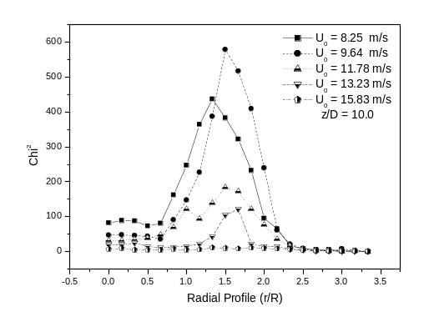
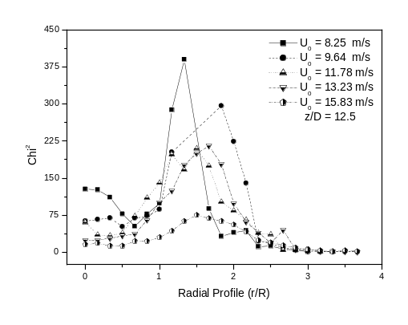
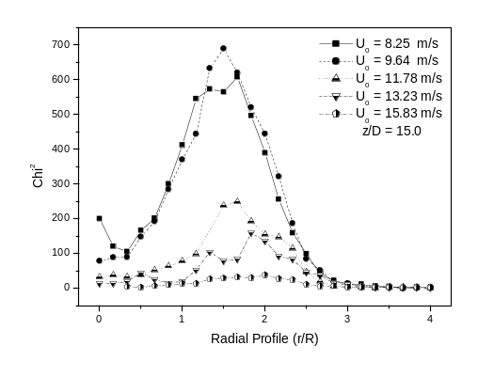
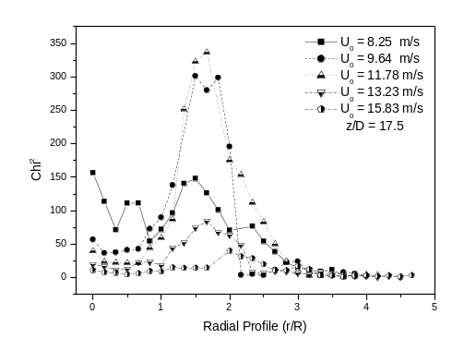
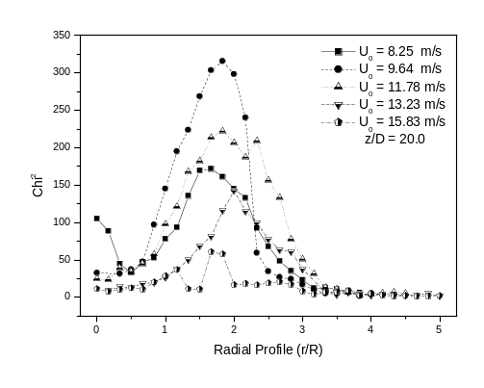
Figure 3: Chi² profiles of the Interparticle-Arrival-Time distribution in a particle laden jet at different gas jet velocities (gas Re-numbers) (from top 1: z/D = 10; 2: z/D = 12.5; 3: z/D = 15; 4: z/D = 17.5; 5: z/D = 20)

The result of the interparticle arrival time analysis within the spray is shown in Figure 4. Here the Chi² distribution is plotted for increasing gas pressures in the central plane of the spray. The distribution illustrates that the maximum of the unsteadiness of the spray and therefore the formation of droplet clusters within the spray is always found in the outer spray edge area. Only for the lowest gas pressure the effect of cluster formation is found also in the spray centre. This effect is due to the remaining liquid jet breakup where the gas flow has minor effects for this low pressure. Here a situation can be found where droplet clusters are formed from the liquid jet breakup itself, a situation that can also be seen in pressure atomizers [3, 8, 9]. The spray cone angle increases with increasing gas pressure.

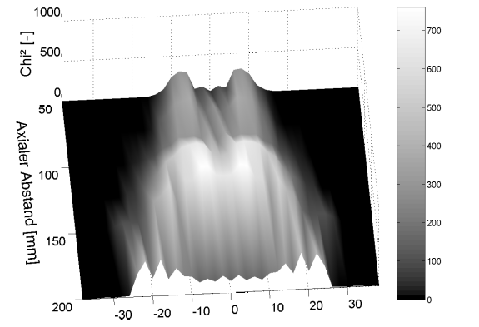
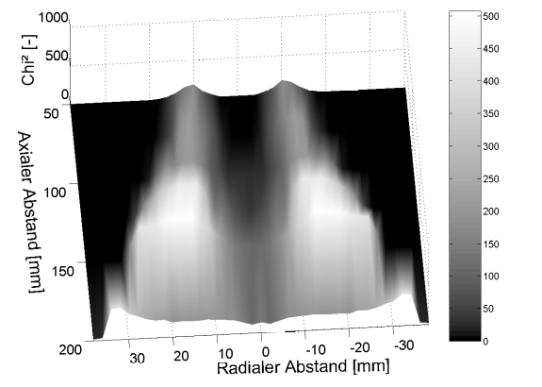
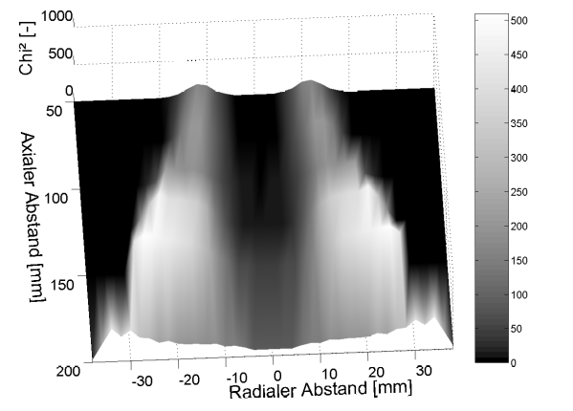
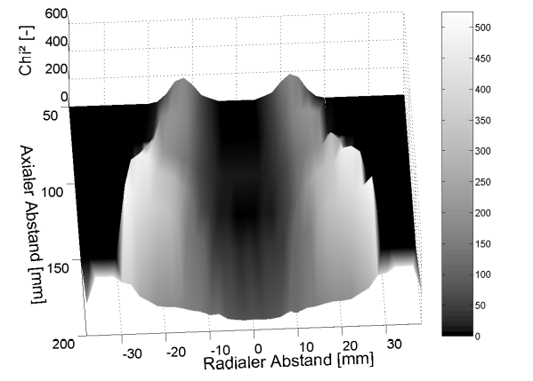

Figure 4: Chi² distribution at different axial and radial positions in the spray of a twin fluid atomizer for varying gas pressures (1: p_{g} = 0.02 MPa; 2: p_{g} = 0.05 MPa; 3: p_{g} = 0.07 MPa; 4: p_{g} = 0.1 MPa)

Figure 5 illustrates the computed instantaneous gas flow field in the shear layer under observation. The formation of large vortices is to be seen.

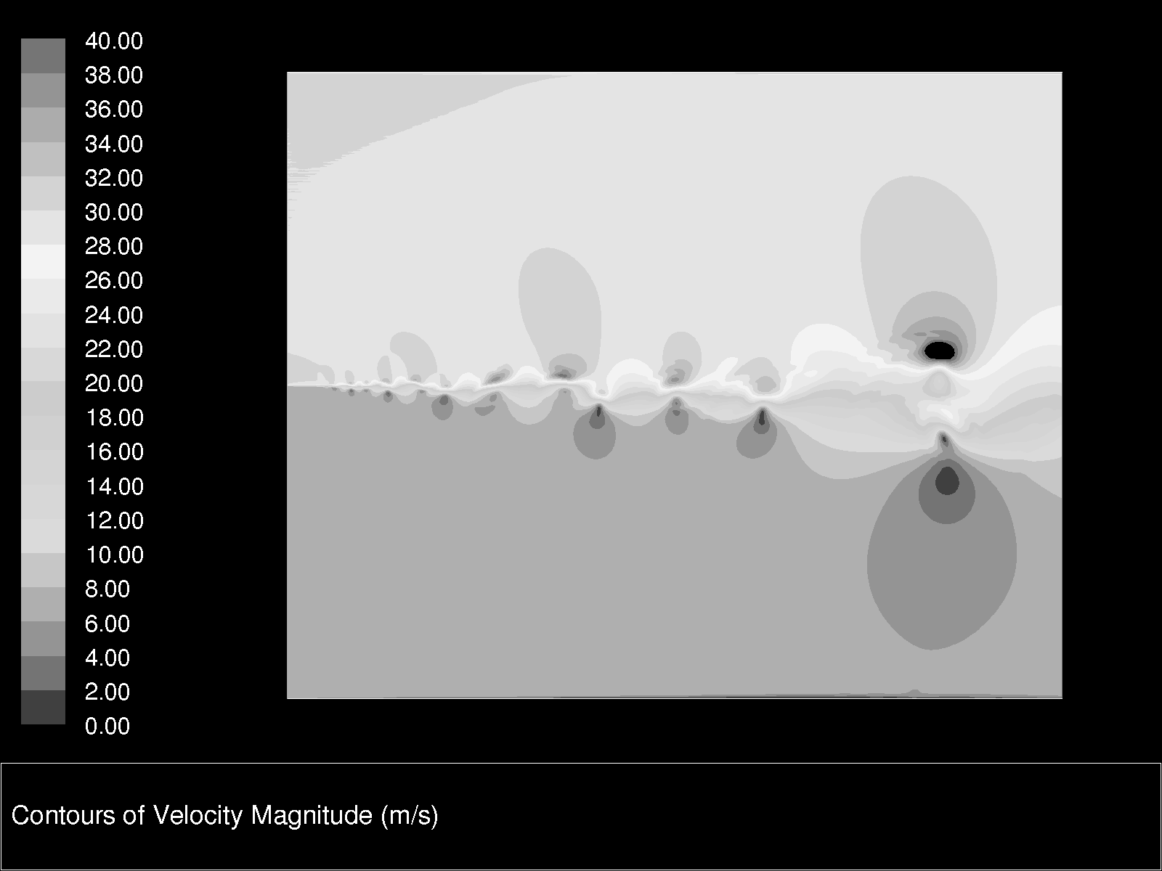

Figure xx: Instantaneous gas velocity contours in the shear layer

The behaviour of different sized droplets in this shear layer vortex flow has been studied. The droplets are specified by their Stokes number. For the shear layer case to be analysed, the calculation of the St depending on droplet size and density is shown in Figure 6.
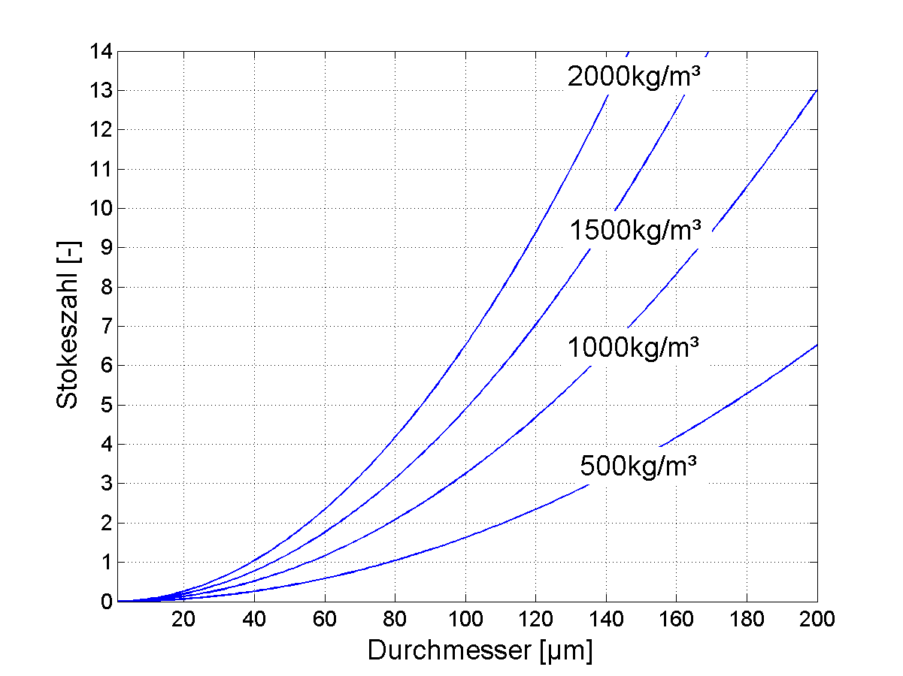

Figure 6: Stokes number of droplets with different density

The behaviour of droplets with St << 1 in the shear layer is shown in Figure 7. The droplets enter the coherent vortices and are more or less homogeneously distributed within each vortex.
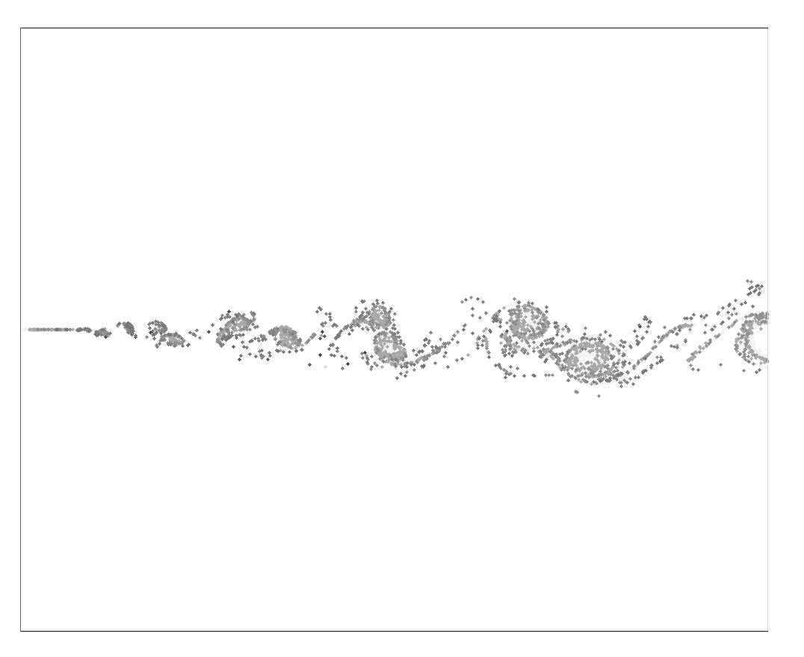
Figure 7: Behaviour of droplets with St << 1

Figure 8 illustrates the droplet behaviour and their interaction with the coherent vortex structure where the droplets Stokes number is in the order of unity. Here one can observe that the droplets are typically concentrating in regions at the vortex edges. The droplets seem to be centrifuged into these regions. A clear tendency of cluster formation and segregation of the particles in this case is obviously.

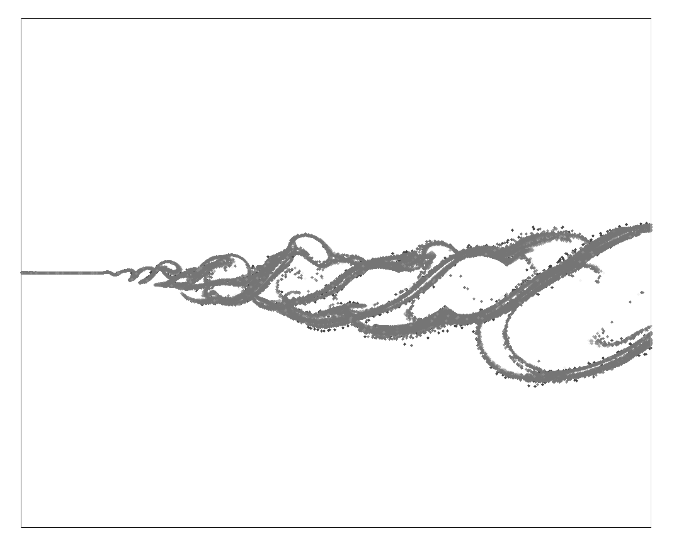

Figure 8: Behaviour of droplets with St ~ 1

Droplets having much larger Stokes numbers (St > 1) are not seriously affected by the gas vortex motion. These larger droplets move on a determined path as to be seen in Figure 9. A lateral dispersion of these droplets is still observed but no ordered response to the vortex motion.

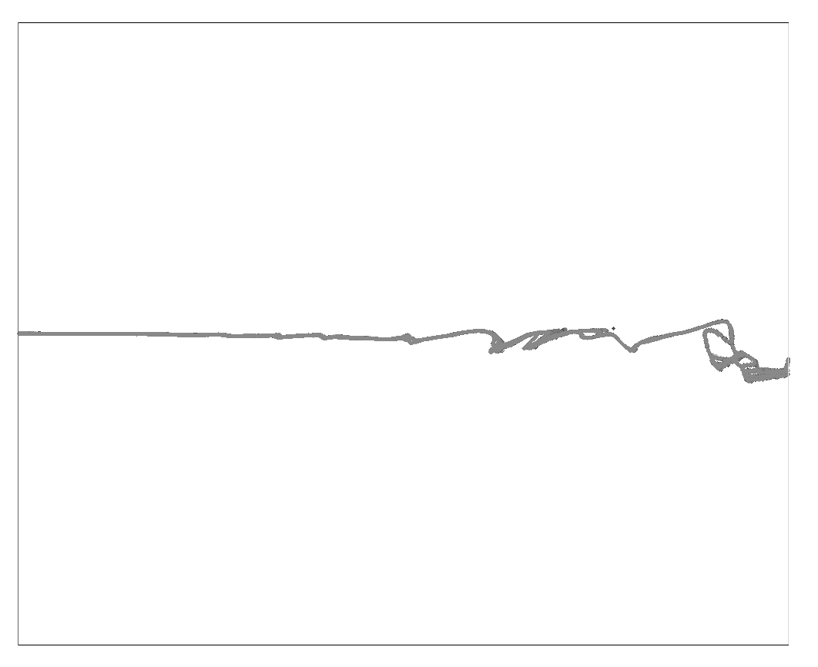

Figure 9: Behaviour of droplets with St > 1

The most intense segregation of droplets occurs at Stokes numbers of unity. The lateral dispersion for this case is studied and illustrated in Figure 10. Here, the particle number rate is sampled throughout the exit plane of the computational domain. The stream wise plane in between the two gas streams is located at y = 35 mm. A lateral dispersion is observed where in the upper (faster moving) gas layer more particles are found as in the lower part, because the mean particle velocity is larger in the upper side of the shear layer. The droplets are accelerated stronger in this area.
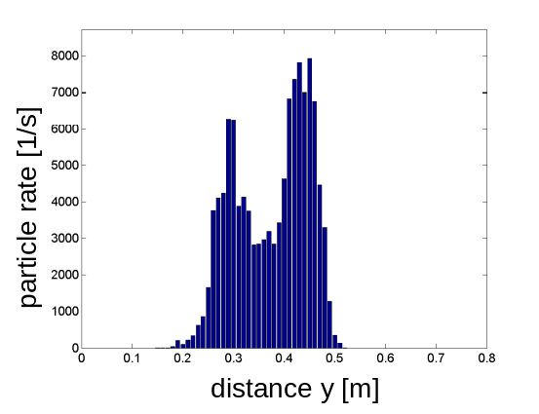

Figure 10: Particle rate in the exit plane of the computational domain

By analysing the interparticle arrival time distribution within these simulations it should be clarified whether this point wise analysis method may be used to identify droplet clustering and segregation. Therefore, the interparticle time distribution in the exit plane of the model has been derived for different sized exit points. A typical sample of the interparticle time distribution is illustrated in Figure 11. The distribution is compared to the theoretical one. In the first bin the calculated interparticle arrival time is larger than the theoretical one while in all other bin these are lower. In terms of the interparticle time analysis and the distinct derivation of steady and unsteady situations in two phase flows, here it is a clear indication that this flow is unsteady. Thus the derivation shows the formation of droplet clusters.

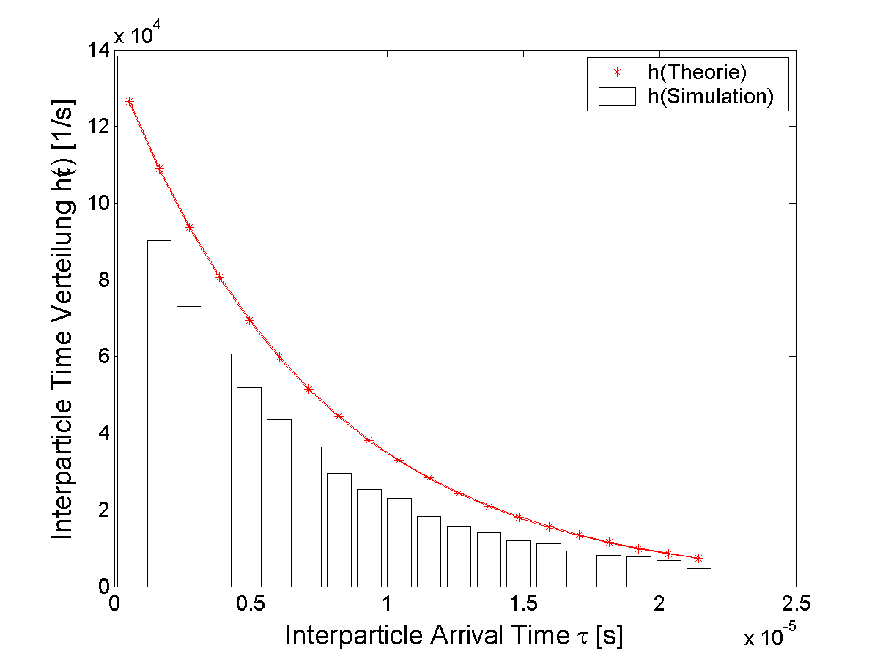

Figure 11: Interparticle arrival time distribution for the simulated case with St ~ 1 in the exit plane

Summary and Conclusions
Spray droplets behaviour is studied especially in the outer edge region of sprays where the interaction of the particulate droplets with large scale coherent vortices is found. The interparticle time distributions are used for certain spray conditions of a twin-fluid atomizer. In addition, for modeling the ideal spray situation, the interparticle arrival time distribution is studied in two-phase jets with solid particles and numerical simulations. It is shown from the various studies that the droplet Stokes number is the main criterion which illustrates the formation of droplet clusters and droplet segregation areas in the spray. The point wise interparticle arrival time analysis is a tool to identify regions of droplet cluster formation.

Acknowledgements

The financial support of this investigation from the German Research foundation (DFG) under grant Fr 912/17 and from the Brazilian National Research Council (CNPq) under grants 290094/2004–6 and 141251/2003-4 is gratefully acknowledged by the authors.

References
[1] Edwards C. F., Marx K. D. (1995). Multipoint statistical structure of the ideal spray, Part I: Fundamental concepts and the realization density. Atomization & Sprays 5: 435– 455.
[2] Edwards C. F., Marx K. D. (1995). Multipoint statistical structure of the ideal spray, Part II: Evaluating steadiness using the interparticle time distribution. Atomization & Sprays 5: 457-505.
[3] Heinlein J., Fritsching U. (2006). Droplet clustering in sprays, Experiment in Fluids 40:464-472.
[4] Luong J.T.K., Sojka P.E. (1999). Unsteadiness in evervescent sprays, Atomization & Sprays 9: 217 - 257
[5] Fritsching U., Körich-Decker R., Heinlein, J. (2006). Tropfen-Cluster Diagnose in Sprays und Jets. Proc. 14. Fachtagung: Lasermethoden in der Strömungsmesstechnik, Braunschweig, Germany.
[6] Gillandt I., Fritsching U. (2001). Derivation and discussion of turbulence energy spectra in dispersed multiphase jet flow, 4th International Conference on Multiphase Flow, New Orleans, USA.
[7] Gillandt I. (2000). Analyse der Turbulenzmodulation im dispersen zweiphasigen Freistrahl. Dissertation, University of Bremen, Shaker Verlag, Aachen.
[8] Heinlein J., Fritsching U. (2004). Detection and evaluation of droplet concentration variations in sprays. DFG – Schwerpunktprogramm Fluidzerstäubung und Sprühvorgänge, Dortmund.
[9] Gillandt I., Fritsching U., Bauckhage K.(2001). Measurement of Phase Interaction in Dispersed Gas / Particle Two Phase Flow, Int. J. Multiphase Flow 27: 1313 - 1332

 Corresponding author: fritsching@iwt.uni-bremen.de Associated Web site: http://www.iwt-bremen.de/vt/mps Proceedings of the 21th ILASS - Europe Meeting 2007

